# **6.2 Pallet Analysis**

## 6.2.1 Pallet Design

The most spatially efficient pallet orientation allows for 33 books per pallet. (See Appendix XX). This setup allows for 96% utilisation of the available pallet surface area. Appendix XX outlines the capacity of both pallet types. Plastic pallets are capable of holding 2574 books, while wooden pallets can hold 1914 books.



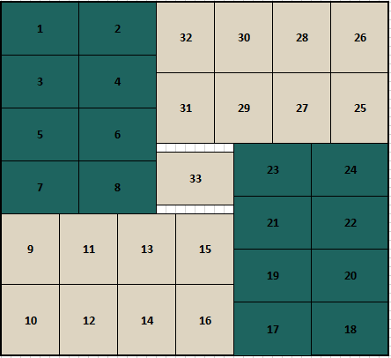

## 6.2.2 Racking

PPL must be prepared for the maximum quarterly output of each language over the course of the contract. Therefore, as outlined in Section XX Warehouse, our team has allowed for this scenario. While this event is unlikely, it is deemed necessary to ensure that Power Printing Ltd can handle this level of demand. This amounts to 627,750 for a three-year contract and 780,750 over the total six-year projections.

Allowing for 300 distinct titles, the tables below (Figure XX) outlines the number of pallets required to accommodate for the 4/6 languages Pulp intend to target. Three-year projections require 120 pallets monthly regardless of type. However, six-year projections require either 192 wooden pallets or 168 plastic pallets. The difference in these figures arises from the greater capacity of the plastic pallets. These figures are calculated on an extreme, worst-case basis whereby books are collected monthly by Pulp Novels. A greater collection frequency would reduce the number of pallets required significantly.

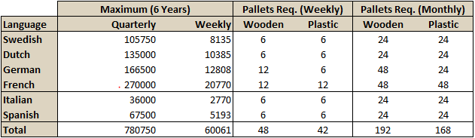

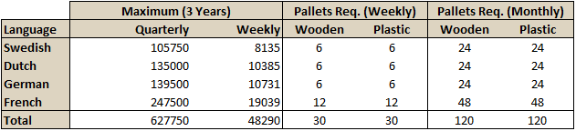

## Appendix XX outlines the number of pallets the warehouse can accommodate. This is largely dependent on the gap between pallets. It is evident that a gap of 0.5m between pallets would be adequate for both pallet type should a three-year contract be accepted. PPL would be required to reduce this distance should the contract be increased to six years.

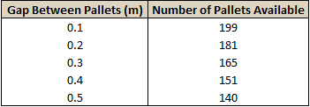

## 6.2.2 Financial Analysis

Appendix XX outlines the costs associated with stocking the warehouse with pallets. This analysis allows for full restocking of pallets following collection by Pulp Novels. The 18-month lifespan of wooden pallets greatly increases the number of pallets required.

Although the cost of plastic pallets is greater than the cost of wooden pallets over both the three-year and six-year projections, the cost is relatively insignificant given the magnitude of the project as a whole. Therefore, we would advise the plastic pallets which will provide superior quality and longevity.

